Instruksi Penggunaan Website

1. Clone Repository from github (<https://github.com/Hinakhina/Webtoon-Recommendation-Website-ML-Project>):

Sebuah gambar berisi teks, cuplikan layar, software, Software multimedia

Konten yang dihasilkan AI mungkin salah.

Use any clone method as preferred (using GitHub Desktop [<https://desktop.github.com/download/>] is recommended)

# If using GitHub Desktop:

1. Click code-> local-> https-> open with GitHub Desktop
2. Clone the repository to an empty folder:

Sebuah gambar berisi teks, cuplikan layar, software

Konten yang dihasilkan AI mungkin salah.

1. The folder will uploaded to the directory
2. Download Node.js installer from <https://nodejs.org/en/download>
3. Download XAMPP for the system database from <https://www.apachefriends.org/>
4. Upload dataset (webtoon_db.sql) to xampp:

# Database Setup (XAMPP)  
1. Open XAMPP and start **MySQL** (run as administrator is recommended), click start on “Apache” and start on “MySQL”

Sebuah gambar berisi teks, cuplikan layar, software, Ikon komputer

Konten yang dihasilkan AI mungkin salah.

2. Open **phpMyAdmin** (`http://localhost/phpmyadmin`) by clicking “Admin” on MySQL

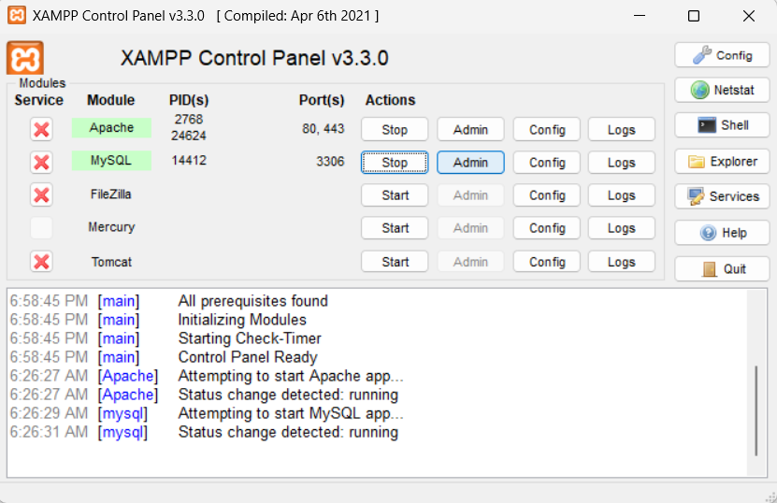

3. Create a new database: `webtoon _db`  
4. Import the SQL file:  
 - Click the `store_it` database  
 - Go to `Import` tab  
 - Choose `database/webtoon_db.sql` from this repo  
 - Click `Go`

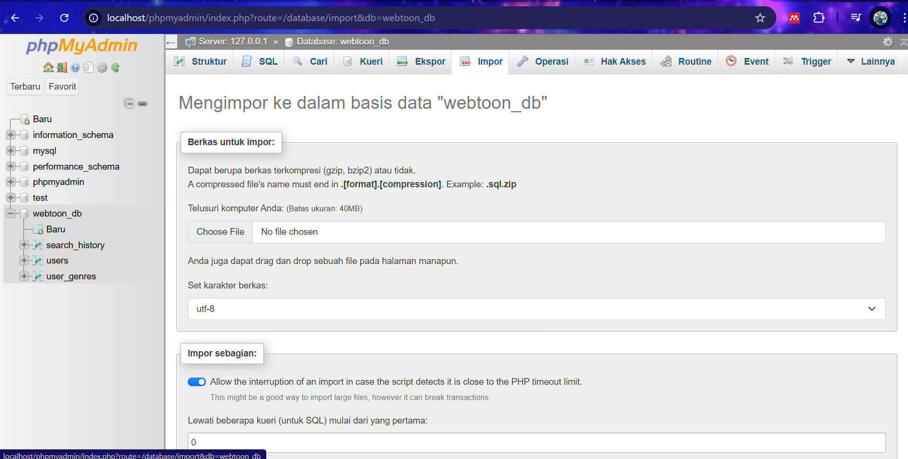

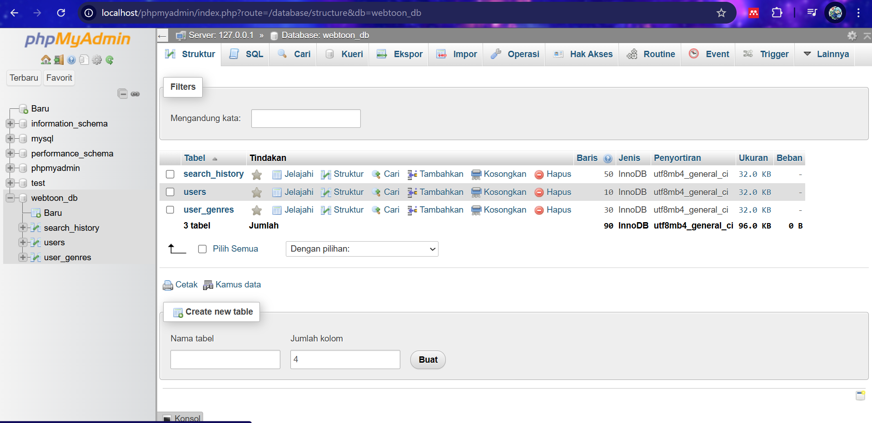  
  
# To reset user_id after clearing database:  
ALTER TABLE users AUTO_INCREMENT = 1;  
ALTER TABLE search_history AUTO_INCREMENT = 1;  
ALTER TABLE user_genres AUTO_INCREMENT = 1;

# NOTES:

If this error occurred: 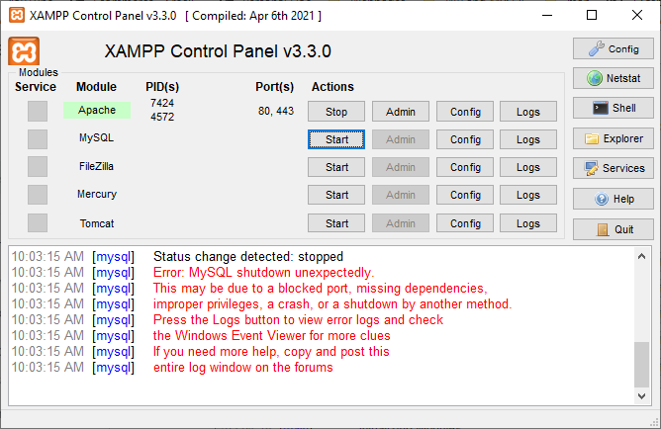

Try solution states on these links:

* <https://www.youtube.com/watch?v=B6PVXmj_QLM> (try this first)
* <https://10web.io/blog/mysql-shutdown-unexpectedly-error/>

1. Open the project (main folder) on Visual Studio Code:

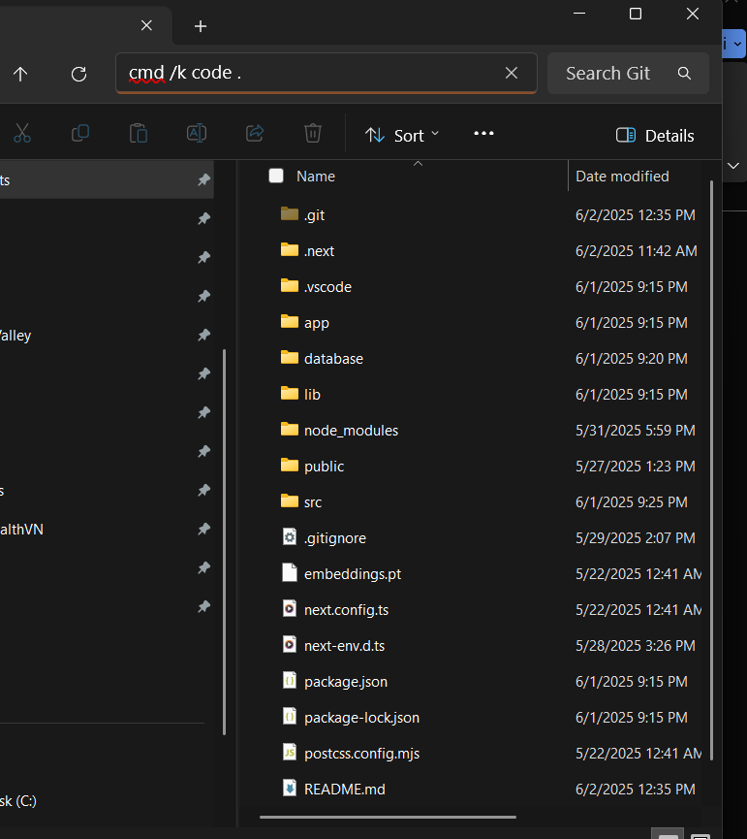

Sebuah gambar berisi teks, cuplikan layar, software, Software multimedia

Konten yang dihasilkan AI mungkin salah.

1. Open the terminal on Visual Studio Code and run these commands:

* pip install (all of the library python needed for the model)
* npm i
* npm run dev

Sebuah gambar berisi teks, cuplikan layar, software

Konten yang dihasilkan AI mungkin salah.

# NOTES:

If this error occurred: Sebuah gambar berisi teks, Font, cuplikan layar

Konten yang dihasilkan AI mungkin salah.

Try this solution:

* <https://blog.csdn.net/hjx020/article/details/111472686> (use translator, in this blog stated that user need to intal Microsoft Visual C++
* <https://www.youtube.com/watch?v=rcI1_e38BWs> (this is the installation tutorial)

1. Open the local host[http://localhost:3000] by clicking ctrl + click to access the website

Sebuah gambar berisi teks, cuplikan layar, Font

Konten yang dihasilkan AI mungkin salah.

(For instructions number 8-11 refer to demo video)

1. From the Log In page, go to register page by clicking “register” hyperlink
2. On the Register page, input username, password, and confirm password. Then, after directing to Questionnaire page, choose 3 favorite genres. Then, the website will direct users to the Main page and give 10 webtoon recommendations.
3. For users that already have an account, just log in and the user will be directed to Main page.
4. For each search input by user in the search bar, after clicking the search icon, the system will give new recommendation (the model used is content based for < 3 search history or hybrid for >= 3 search history)
5. To Close the website server, go to the terminal on the VS Code, then click(or spam) ctrl+c:

Sebuah gambar berisi teks, cuplikan layar, software, Software multimedia

Konten yang dihasilkan AI mungkin salah.  
  
  
  
## Train Model Code:  
https://colab.research.google.com/drive/1UOBSMICdV_H0a1Ntv75CN7MKFsQPJPEM?usp=sharing  
  
# Presentation File:  
<https://www.canva.com/design/DAGpIPJUyZ0/YlogpwCEXFFR7jrcGCM3aA/view?utm_content=DAGpIPJUyZ0&utm_campaign=designshare&utm_medium=link2&utm_source=uniquelinks&utlId=h88b3c4ceae>